|  |  |  |  |  |  |  |  |  |
| --- | --- | --- | --- | --- | --- | --- | --- | --- |
| |  | | --- | | Yunteng VCT-668 tripod | |  |  |  |  |  |  | | --- | --- | --- | --- | |  |  |  |  | |  | **Featured information**  The Yunteng VCT-668 tripod supports easy shooting, 3-pin focus point stabilization with a non-slip rubber stand, and screw locks that allow quick adjustment of shooting angle or movie shooting  **Price: 50$**  **Specifications:**   * **Weight:** 1.3 kg * **Max height:** 152 cm * **Minimum height:** 46 cm * **Load bearing:** 3 Kg |

**Description:**

#### **Yunteng VCT-668 flexible design, easy to adjust**

The Yunteng VCT-668 tripod brings beautiful photos without having to spend too much effort to calibrate the machine. All thanks to the integration of the water drop balance gauge and flexible design, easy to rotate in many directions.

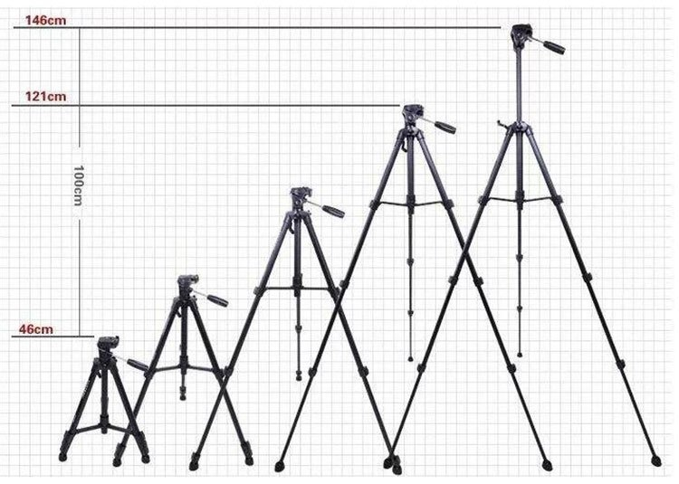

Weighing in at just 1.3 kg, this tripod is very lightweight, making it comfortable to move. The metal leg is also coated with an antioxidant coating, creating durability for the product. The minimum length of only 46 cm helps it always accompany you on pinic trips and travel.

The tripod is designed specifically for cameras and camcorders that are compact, easy to move, and easy to use. Not only does it support photography, eliminate shake, it also provides flexibility to help you unleash your creativity with your photos.